# T. Y. B. Tech (Electrical and Computer Engineering)

**Trimester: VI Subject: Electric vehicle technology**

# Name: Shreerang Mhatre Class: TY BTECH EL&CE

**Roll No: 52 Batch: A2**

# Experiment No: 07

**Name of the Experiment:** Simulation of drive cycle for EV testing in MATLAB

**Marks**

**Teacher’s Signature with date**

# Performedon Submitted on:

**Aim:** To understand simulation of drive cycle for EV testing in MATLAB

**Resources:** Matlab 2022, Simscape toolbox

**Theory:**

Drive Cycle Definition:

* Defines the speed profile and driving conditions experienced by the EV over time. Vehicle Dynamics:
* Newton's laws of motion govern acceleration, deceleration, and net force calculations. Battery Model:
* Models the EV battery's behavior including State of Charge (SoC), discharge, and charge rates. Motor Model:
* Represents the electric motor's power output, torque, and efficiency characteristics. Controller Design:
* Manages power flow, torque distribution, and regenerative braking. Simulation Setup:
* Defines input signals, initial conditions, and simulation parameters. Simulation Execution:
* Runs the simulation to generate data on speed, battery SoC, power, and energy consumption. Analysis and Visualization:
* Analyzes results to evaluate EV performance in terms of efficiency, range, and energy usage.

**Procedure:**

**Define Drive Cycle**:

Choose a drive cycle profile such as UDDS or HWFET.

Define parameters like speed variations, acceleration, and deceleration.

**Vehicle Dynamics:**

Implement equations for vehicle motion based on Newton's laws.

Calculate net force, power for acceleration, air drag power, and rolling resistance power.

**Battery Model:**

Create a battery model with variables for State of Charge (SoC), capacity, discharge rate, and charge rate.Simulate battery behavior during the drive cycle, considering voltage, current, and efficiency.

**Motor Model:**

Develop a motor model with power output, torque characteristics, and efficiency. Calculate motor power and efficiency based on torque and angular speed.

**Controller Design:**

Design control algorithms for power management, torque distribution, and regenerative braking. Implement strategies to optimize energy usage based on speed, acceleration, and battery SoC.

**Simulation Setup:**

Use MATLAB's Simulink or scripts to set up the simulation environment.

**Reference link:** [https://www.youtube.com/watch?v=tLGKy_Qebu0](http://www.youtube.com/watch?v=tLGKy_Qebu0)

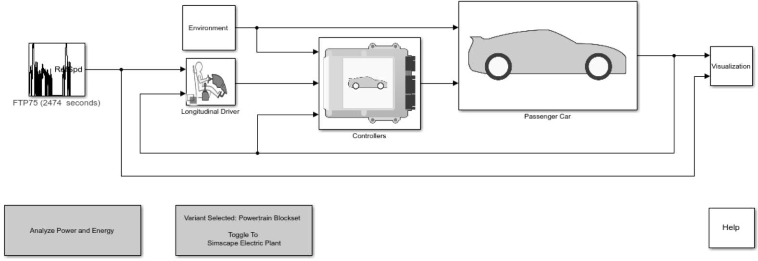**Conclusion-** The simulation of the Electric Vehicle drive cycle in MATLAB demonstrated efficient power management strategies, insightful battery behavior analysis, and highlighted the importance of motor performance in optimizing energy consumption and overall EV performance.

